WEEK 6 – PRODUCT REVIEW AND RATING MANAGEMENT SYSTEM
1. Introduction
The Product Review and Rating Management System is the sixth module of the E-Commerce Database System. It extends the existing database by allowing customers to submit reviews and ratings for products they have purchased or used.
This module stores customer feedback, product ratings, review descriptions, and review dates. It helps maintain customer feedback records and provides useful information about product quality and customer satisfaction.
The system also supports product-wise rating analysis, customer review history, average rating calculation, and identification of highly rated and poorly rated products.
Main Objectives
- Allow customers to submit product reviews and ratings.
- Store review details, including customer ID, product ID, rating, review text, and review date.
- Establish relationships between Customer, Product, and Review tables.
- Ensure that ratings remain within the permitted range.
- Prevent duplicate reviews for the same customer and product.
- Retrieve customer-wise review history.
- Calculate average ratings for each product.
- Identify highly rated and poorly rated products.
- Generate product review and rating reports.
2. Review Table Design
Column | Data Type | Constraint | Description
Review_ID | INT | Primary Key | Unique identification number for each review
Customer_ID | INT | NOT NULL, Foreign Key | Identifies the customer who submitted the review
Product_ID | INT | NOT NULL, Foreign Key | Identifies the reviewed product
Rating | INT | NOT NULL, CHECK | Customer rating for the product
Review_Text | VARCHAR(1000) | Optional | Written feedback provided by the customer
Review_Date | DATE | NOT NULL, DEFAULT | Date on which the review was submitted
Rating range: 1 to 5, where 1 represents the lowest rating and 5 represents the highest rating.
A UNIQUE constraint on (Customer_ID, Product_ID) can be used to prevent the same customer from submitting multiple reviews for the same product. This design allows each customer to review a particular product only once.
3. Relationships and Constraints
The Review table is connected to the existing Customer and Product tables through foreign keys.
Relationship Diagram
CUSTOMER (1) ───── (M) REVIEW (M) ───── (1) PRODUCT
Relationship Explanation
Relationship | Type | Description
Customer → Review | One-to-Many | One customer can submit reviews for multiple products
Product → Review | One-to-Many | One product can receive reviews from multiple customers
The Customer and Product tables have a many-to-many relationship through the Review table. A customer can review several products, and a product can receive reviews from several customers.
Constraints Used
- PRIMARY KEY: Uniquely identifies each review using Review_ID.
- FOREIGN KEY: Connects the Review table with Customer and Product.
- NOT NULL: Ensures that essential fields such as Customer_ID, Product_ID, and Rating are provided.
- UNIQUE: Prevents duplicate reviews by the same customer for the same product.
- CHECK: Restricts the rating to values between 1 and 5.
- DEFAULT: Automatically assigns the current date when Review_Date is omitted, if the database and column definition support this default.
4. Sample Review Data
The following sample records demonstrate how customer feedback can be stored in the Review table. The Customer_ID and Product_ID values must exist in the corresponding tables before these records are inserted.
Review ID | Customer ID | Product ID | Rating | Review Text | Review Date
5001 | 2001 | 101 | 5 | Excellent product and good quality. | 2026-10-01
5002 | 2002 | 102 | 4 | Good product and value for money. | 2026-10-02
5003 | 2003 | 104 | 3 | Average quality, but it works well. | 2026-10-03
5004 | 2004 | 108 | 5 | Very useful product with great performance. | 2026-10-04
5005 | 2005 | 112 | 4 | Satisfied with the product. | 2026-10-05
5006 | 2001 | 113 | 2 | The quality could be improved. | 2026-10-06
5007 | 2002 | 106 | 5 | Excellent quality and fast performance. | 2026-10-07
5008 | 2003 | 114 | 3 | The product is satisfactory. | 2026-10-08
5009 | 2004 | 111 | 4 | Good product with useful features. | 2026-10-09
5010 | 2005 | 110 | 1 | Not satisfied with the product quality. | 2026-10-10
These sample records contain different ratings and review descriptions to demonstrate positive, average, and negative customer feedback.
5. Product Review Management Operations
The Product Review and Rating Management System supports the following database operations.
5.1 Create a Review
A new review is added by inserting a record into the Review table with a valid Customer_ID, Product_ID, Rating, and other optional information.
5.2 View All Reviews
All stored reviews can be retrieved to display customer feedback, ratings, review dates, and associated product information.
5.3 Update a Review
Existing review information can be modified when corrections are required. For example, the review text or rating may be updated if the system permits customers to edit their feedback.
5.4 Delete a Review
A review can be deleted when it is invalid, duplicated, or removed according to the application's review policy.
5.5 Validate Ratings
The CHECK constraint ensures that the rating is between 1 and 5. Invalid values such as 0 or 6 should be rejected when the database engine enforces the constraint.
5.6 Prevent Duplicate Reviews
The UNIQUE constraint on (Customer_ID, Product_ID) prevents the same customer from creating another review for the same product. If multiple reviews per customer are required in the future, this constraint can be redesigned.
6. Customer Feedback and Rating Analysis
The Review table supports several useful reports for understanding customer satisfaction.
Report | Purpose
Complete review report | Displays all review records with customer and product details
Customer-wise review history | Lists the reviews submitted by each customer
Product-wise review report | Displays the reviews and ratings received by each product
Average rating by product | Calculates the average rating for each product
Highest-rated products | Identifies products with the highest average ratings
Lowest-rated products | Identifies products with the lowest average ratings
Total reviews per product | Counts the number of reviews received by each product
Rating distribution | Counts how many 1-star, 2-star, 3-star, 4-star, and 5-star ratings each product receives
Customer rating summary | Shows the ratings submitted by each customer
Overall average rating | Calculates the average rating across all reviews
Importance of Rating Analysis
- Helps customers make informed purchasing decisions.
- Identifies products that receive positive customer feedback.
- Highlights products that may require quality improvements.
- Helps sellers understand customer satisfaction.
- Supports data-driven product and business decisions.
7. SQL Operations and Queries
The following operations can be performed in MySQL Workbench to manage reviews and generate reports.
7.1 Display All Reviews
Retrieve all records from the Review table to verify the stored information.
7.2 Display Reviews with Customer and Product Details
Join the Review table with Customer and Product to display customer names, product names, ratings, review text, and review dates in a single report.
7.3 Calculate Average Product Rating
Use the AVG aggregate function and GROUP BY clause to calculate the average rating for each product.
7.4 Count Reviews per Product
Use COUNT and GROUP BY to determine how many customers have reviewed each product.
7.5 Identify Highly Rated Products
Calculate the average rating for every product and sort the results in descending order to identify products with the highest average ratings.
7.6 Identify Poorly Rated Products
Sort the product rating report in ascending order to identify products that may require improvement.
7.7 Display Customer Review History
Retrieve reviews for a particular customer by filtering with Customer_ID or Customer_Name.
7.8 Generate Rating Distribution
Group the review records by Product_ID and Rating to determine the number of reviews for each rating level.
These operations demonstrate the use of SELECT, JOIN, WHERE, ORDER BY, GROUP BY, COUNT, and AVG in SQL.
8. Query Output Screenshots
- Review table structure.
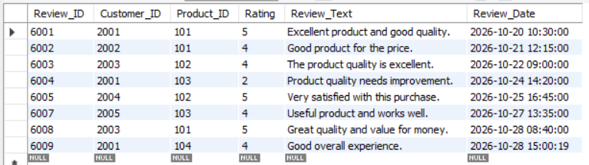
- Complete Review table with sample records.
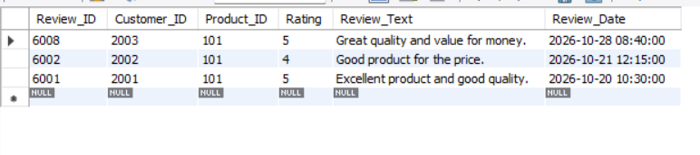
- Review table showing customer and product relationships.
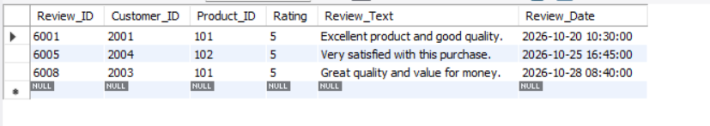
- Customer-wise review history.
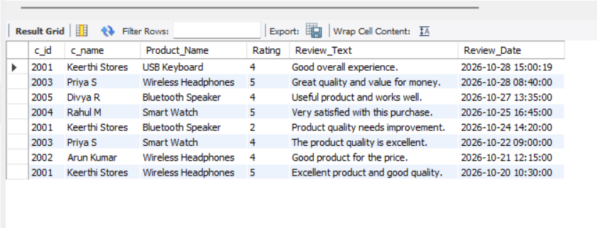
- Product-wise review report.
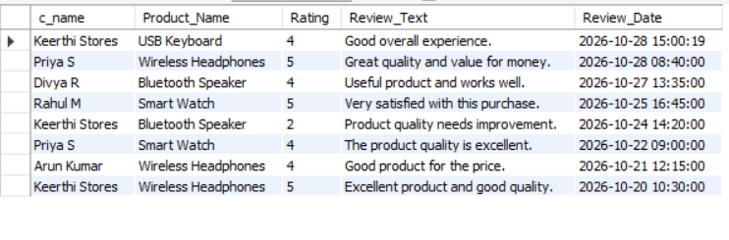

- Average rating for each product.
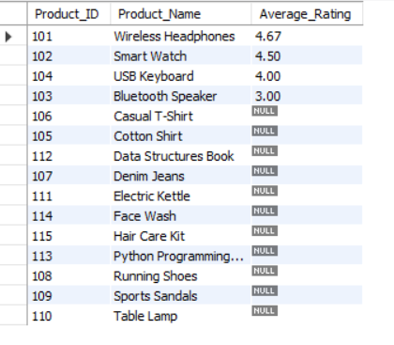
- Total number of reviews per product.
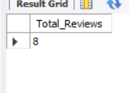
- Rating distribution for each product.
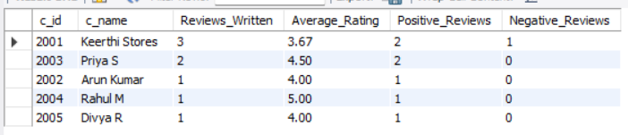
- Overall average product rating.
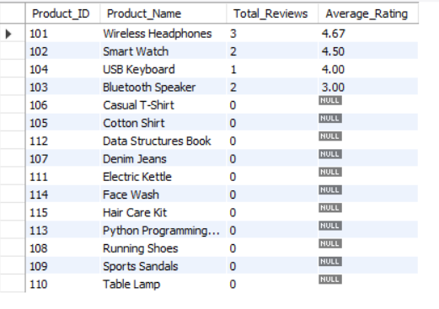
- Successful insertion of a valid review.
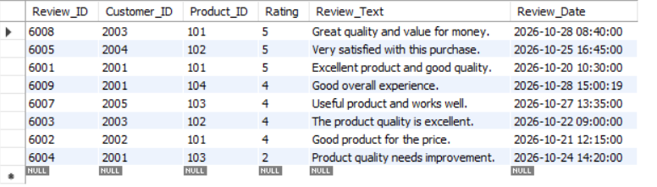
9. Conclusion
The Product Review and Rating Management System is an important module of the E-Commerce Database System. It enables customers to provide feedback and ratings for products while maintaining structured and reliable review records.
The Review table establishes relationships with the Customer and Product tables through foreign keys. Primary keys, NOT NULL, UNIQUE, CHECK, and DEFAULT constraints help maintain data integrity and prevent invalid or duplicate data.

